|  |  |
| --- | --- |
| **Arduino**  **Prototyping Protocol** | **ID: PP-1** |
|  |  |

**Date Written –** 04/04/2020

**Date Revised –** 04/06/2020

**Author:** Kathryn Garvey, Ashleigh Hanne, Jessica McPhee, Andrew Smith

**Protocol Description – Arduino / Micropump Prototyping Protocol**

A microfluidic pump prototype was created using a printed circuit board (PCB) (PT2), a stepper motor (PT3), push button (PM3), LED lighting (PM2), resistors (PM4, PM5), a capacitor (PM6), and includes an interactive Arduino interface (UI) (PT1).

A microfluidic pump case was designed in Solidworks (PT6). Once the design was completed in CAD format (CF6 & CF8), it was converted to a .STL file, a G code using Slic3r (PT5), and an X3G file using GpxUI (PT5) for 3D printing; an assembly was created from the printed parts.

A PCB was designed and assembled according to the wiring schematic shown in Figure 1. Safety glasses (PT3) were worn during circuit assembly, and a soldering gun (PT2) and solder (PM1) were used to connect circuit components to the pads of the PCB. The 3D printed motor enclosure (CF8) was attached to the stepper motor using 20.0 mm M3 screws (PM10). The 3D printed bearing hub was secured via washer (PM8) and flanged ball bearing (PM7) onto an 8.0mm M3 screw (PM12). This assembly was secured into the base of the bearing hub. Nuts were threaded onto each screw from the underside and placed on the center of the stepper motor casing. The tubing was threaded through the holes inside the 3D printed enclosure, avoiding the bearings, and secured using 6.0mm screws. Refer to Figure 2 in the schematic section for completed assembly.

Arduino software (PT1) was used to write and compile the code for programming the microfluidic pump prototype. Upon assembly completion and upload of the code, the pump can undergo protocol testing (MTD-1).

**Schematics**

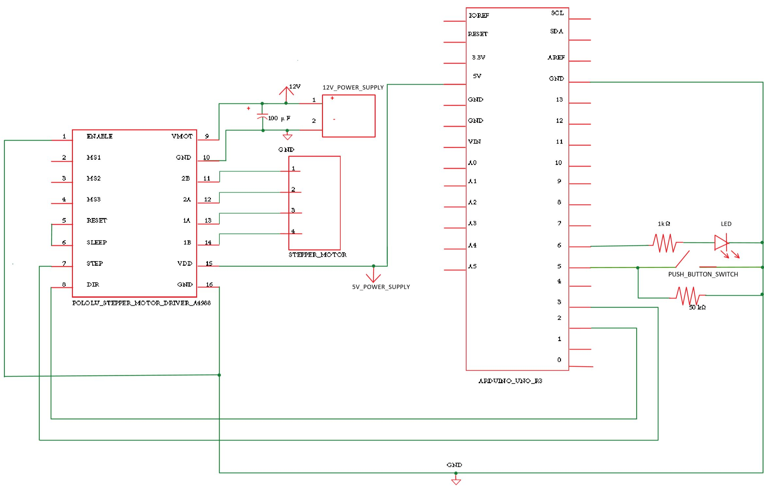

**Figure 1.** Wiring schematic for the PCB

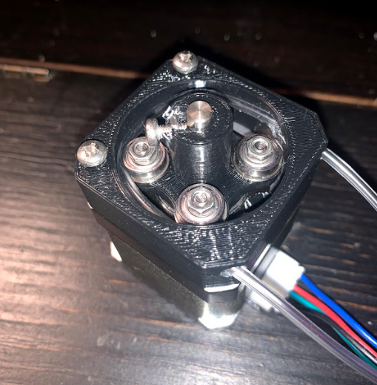

**Figure 2.** Roller Bearing Pump Assembly

Tables 1 and 2 below display the lists of equipment, tools, and materials used to prototype the microfluidic pump.

**Table 1. Tools and Equipment**

|  |  |  |  |  |
| --- | --- | --- | --- | --- |
| **ID** | **Tool** | **Name / # if applicable** | **Location** | **Purpose** |
| PT1 | Arduino Software |  | Design Lab | User Interface |
| PT2 | Soldering Gun |  | Design Lab | Secure connection to PCB |
| PT3 | Safety Glasses |  | Design Lab | PPE |
| PT 4 | 3D Printer, Flashforge Creator Pro | Ringo | Design Lab | 3D Printing |
| PT5 | GpxUI |  | Design Lab Computer | Converting G-code into X3G file for FDM Printing on Flashforge |
| PT5 | Slic3r |  | Design Lab Computer | Converting stl file into G-code |
| PT6 | Solidworks |  | Design Lab | CAD for solid model |
| PT7 | Pliers |  | Design Lab | For removing printed parts from 3D printer bed plate |

**Table 2. Materials**

|  |  |  |  |
| --- | --- | --- | --- |
| **ID** | **Material** | **Name/ If Applicable** | **Purpose** |
| PM1 | Solder | Wire Wrapping Wire, PCB solder PVC coated Tin plated copper wire 20AWG 105 oC | To connect circuit components to PCB |
| PM2 | LED Light | NA | Indicator lighting |
| PM3 | Push Button | NA | On/Off switch |
| PM4 | 1kΩ Resistor | NA | Component of circuit |
| PM5 | 50kΩ Resistor | NA | Component of circuit |
| PM6 | 100μF Capacitor | NA | Component of circuit |
| PM7 | ⅛” x ⅜” OD Flanged Ball Bearings | NA | Component of pump assembly |
| PM8 | M3 Washers | NA | Component of pump assembly |
| PM9 | Nuts | NA | Component of pump assembly |
| PM10 | 20.0mm M3 Screws | NA | Component of pump assembly |
| PM11 | 6.0mm Screw | NA | Component of pump assembly |
| PM12 | 8.0mm Screws | NA | Component of pump assembly |
| PM13 | PCB | Austor AMA-17-549 | Circuit component |
| PM14 | Stepper Motor | StepperOnline-Model: 190625000801 | Motor driver |
| PM15 | Tubing | NA | Component of pump assembly |
| PM16 | (Polylactic Acid (PLA) 1.75mm Hatchbox, Black) | 3D Printing | Pump assembly |

**Table 3. Computer Files**

|  |  |  |  |
| --- | --- | --- | --- |
| **ID** | **FileName / Link** | **Purpose** | **Location** |
| CF1 | WiringSchematic.pdf | To show proper assembly of PCB and components | Micropump/CompFiles/WiringSchematic.pdf |
| CF2 | <https://content.arduino.cc/assets/UNO-TH_Rev3e_sch.pdf> | Provides the circuit schematic of the arduino |  |
| CF3 | https://www.omc-stepperonline.com/download/17HS15-1504S-X1.pdf | Provides information regarding the stepper motor |  |
| CF4 | <https://www.robotshop.com/media/files/PDF/datasheet-1182.pdf> | Provides information regarding the A4988 stepper motor driver |  |
| CF5 | https://www.sparkfun.com/datasheets/Components/LED/COM-09590-YSL-R531R3D-D2.pdf?_ga=2.194229549.1693224037.1586127836-387832931.1586127836 | Provides information regarding the LED light |  |
| CF6 | Bearing_hub_spring_new.SLDPRT | Solidworks file of the bearing hub part | /Micropump/CompFiles/Pump_SW_Files/Bearing_hub_spring_new.SLDPRT |
| CF7 | Bearing_hub_spring_new2.SLDPRT | Solidworks file of a different iteration of the bearing hub part | /Micropump/CompFiles/Pump_SW_Files/Bearing_hub_spring_new2.SLDPRT |
| CF8 | Motor_enc_U.SLDPRT | Solidworks file of the stepper motor enclosure part | /Micropump/CompFiles/Pump_SW_Files/Motor_enc_U.SLDPRT |
| CF9 | micropumpUI.ino | Arduino code for uploading to processor | /Micropump/CompFiles/micropumpUI/micropumpUI.ino |